




THE YENEPOYA INSTITUTE OF ARTS SCIENCE
COMMERCE AND MANAGEMENT

FINAL REPORT

ON
Design and Development of Identity Security
Framework for Finance

Student Name: Amritha Jayakumar Guided by:Thanziha
REG NO: 23BSCED003

CERTIFICATE

This is to certify that the project work entitled Design and Development of Identity Security Framework for Finance has been successfully carried out by Amritha Jayakumar(Reg. No. 23BSCED003), student of the 3rd Year B.Sc.(Cybersecurity, Ethical Hacking & Data Analytics) under the supervision and guidance of Ms. Tanziha, Asst. Professor, Department of Computer Science, Yenepoya Institute of Arts, Science, Commerce and Management. This dissertation is submitted in partial fulfilment for the award of degree in Bachelor of Computer Science by Yenepoya (Deemed to be University) during the academic year 2025-26.

Internal Guide: Chairperson

Internal Examiner: External Examiner

PRINCIPAL

Dr. Jeevan Raj

The Yenepoya Institute of Arts,

Science, Commerce and Management

(Deemed To be university)

Submitted for the Viva-Voce Place: Mangalore

DECLARATION

I, Amritha Jayakumar, a student of BSc (Cybersecurity, Ethical Hacking & Data Analytics) at Yenepoya Institute of Arts, Science, Commerce and Management, Balmatta, Mangalore, affiliated with Yenepoya (Deemed to be University), hereby declare that the project titled “Design and Development of Identity Security Framework for Finance” is a genuine and original work carried out by me as part of my academic curriculum.

This report presents the design, development, and implementation of a secure web-based banking system focusing on identity security, access control, cryptographic credential management, and secure web application development. It documents the methodologies, technical approaches, system architecture, and security mechanisms implemented in accordance with established cybersecurity practices and industry standards.

Furthermore, I acknowledge the guidance and support received from my institutional guide, Ms. Tanziha, and the faculty of Yenepoya Institute of Arts, Science, Commerce and Management. Their valuable insights and continuous assistance have been instrumental in the successful completion of this project.

Student Signature: ___________________________

Name: Amritha Jayakumar

Institution Guide Signature: ___________________________

Name: Ms. Tanziha
Institute: Yenepoya Institute of Arts, Science, Commerce and Management

HOD Signature: ___________________________

Name: Dr. Rathnakar Shetty P
Head of Department of CS
Institute: Yenepoya Institute of Arts, Science, Commerce and Management

Date: ___________________________

ACKNOWLEDGEMENT

I sincerely express my gratitude to Yenepoya Institute of Arts, Science, Commerce and Management, affiliated with Yenepoya (Deemed to be University), Mangalore, for providing me with the opportunity to undertake this project as part of my academic curriculum.

I extend my heartfelt thanks to Dr. Jeevan Raj, Principal, for his continuous support and for fostering an environment that encourages academic excellence and practical learning. I also express my sincere appreciation to Dr. Rathnakar Shetty P, Head of the Department of Computer Science, for his valuable guidance and encouragement throughout the course of this project.

I would like to express my sincere gratitude to my project guide, Ms. Tanziha, for her constant support, constructive feedback, and academic mentorship. Her guidance played a crucial role in shaping the successful development of this project and in strengthening my understanding of secure system design and implementation.

This project, titled “Design and Development of Identity Security Framework for Finance,” provided me with the opportunity to gain practical exposure in areas such as identity security, authentication mechanisms, cryptographic credential management, and secure web application development. The experience significantly contributed to enhancing my technical knowledge and problem-solving skills in the field of cybersecurity.

I am also thankful to all the faculty members of the department for their support and encouragement. Finally, I express my heartfelt gratitude to my family and friends for their continuous motivation and support throughout the completion of this project.

Name/Reg No: Amritha Jayakumar / 23BSCED003
Date: _____________________

ABSTRACT

Modern web-based financial systems are prime targets for cyber threats due to the sensitive nature of user data and financial transactions. The increasing frequency of attacks such as credential theft, brute-force login attempts, session hijacking, and cross-site vulnerabilities necessitates the development of secure, reliable, and user-centric banking applications with robust identity protection mechanisms.

This project presents the design and implementation of NexaBank — Identity Security Framework, a secure web-based banking system developed using the Flask framework. The system integrates multiple layers of security, including two-factor authentication (2FA), cryptographic credential storage, session management, and protection against common web-based attacks, to ensure a secure and resilient user experience.

The authentication mechanism combines password-based verification with time-sensitive One-Time Password (OTP) validation, significantly reducing the risk of unauthorized access. User credentials are securely stored using industry-standard cryptographic hashing techniques such as bcrypt and scrypt through Werkzeug, ensuring that sensitive information remains protected even in the event of a database breach.

To safeguard against web application vulnerabilities, the system implements Cross-Site Request Forgery (CSRF) protection using Flask-WTF tokens and incorporates input validation mechanisms to mitigate risks associated with Cross-Site Scripting (XSS) and injection attacks. Additionally, a brute-force prevention system is enforced through an account lockout mechanism after multiple failed login attempts.

The application provides a comprehensive banking feature set, including secure fund transfers, beneficiary management, fixed deposit handling, account statement generation, and a support ticket system, all operating within a controlled and authenticated environment. A tamper-evident audit logging system records all login activities with details such as IP address, timestamp, and event status, enabling transparency and accountability for both users and administrators.

The system demonstrates how secure design principles can be effectively integrated into a functional banking application, offering both practical usability and strong security assurance. The results highlight the effectiveness of layered security implementation in mitigating common cyber threats and improving overall system reliability.

Table of Contents

1. Background

1.1 Aim

1.2 Technologies

1.3 Hardware Architecture

1.4 Software Architecture
1.4.1. Model Layer — Data and Business Logic (models.py)
1.4.2 View Layer — User Interface (/templates and /static)
1.4.3. Controller Layer — Application Logic (app.py)
1.4.4 Security Middleware Layer

2. System

2.1 Requirements

2.2.1 Functional requirements

2.2.2 User requirements

2.2.3 Environmental requirements

2.2 Design and Architecture

2.3 Implementation

2.4 Testing

2.5 Graphical User Interface (GUI) Layout

2.6 Customer testing

2.7 Evaluation

3. Snapshots of the Project

4. Conclusions

5. Further development or research

6. References

7. Appendix

1. BACKGROUND

The financial services industry has undergone a significant and continuous transformation over the past two decades, driven primarily by rapid advancements in digital technology and the widespread adoption of internet-enabled devices. Traditional banking systems, which once relied heavily on physical branches and manual processes, have gradually transitioned into fully digital platforms that provide users with instant, real-time access to financial services.
Globally, the rise of internet banking and mobile banking applications has redefined how individuals interact with financial institutions. Customers are no longer required to visit bank branches for routine activities such as balance inquiries, fund transfers, or account management. Instead, these services are now accessible through secure web portals and mobile applications, offering convenience, speed, and efficiency.
In the Indian context, this transformation has been particularly rapid and impactful. Government-led initiatives such as Digital India have played a crucial role in promoting digital literacy and encouraging the adoption of online services. The increasing affordability of smartphones and the expansion of high-speed internet connectivity have further accelerated this shift, enabling millions of users across both urban and rural regions to participate in the digital economy.
One of the most significant developments in India's digital banking ecosystem is the introduction of the Unified Payments Interface (UPI) by the National Payments Corporation of India (NPCI). UPI has revolutionized digital payments by enabling seamless, real-time fund transfers between bank accounts using simple identifiers such as mobile numbers or virtual payment addresses. As of 2024, UPI processes over ten billion transactions per month, making it one of the most widely used digital payment systems in the world.
In addition to UPI, other payment systems such as Immediate Payment Service (IMPS) and National Electronic Funds Transfer (NEFT) have contributed to the availability of round-the-clock banking services. Most commercial banks now offer comprehensive internet banking portals, which serve as the primary interface for customer interactions.
However, the rapid digitization of banking services has also introduced new security challenges. As financial systems become increasingly interconnected and accessible via the internet, they also become more vulnerable to cyber threats. Internet banking applications are particularly attractive targets for attackers due to the sensitive nature of the data they handle and the potential for direct financial gain.
Common attack vectors targeting banking systems include phishing attacks, where users are tricked into revealing their login credentials through fraudulent websites or emails. Brute-force attacks attempt to gain unauthorized access by systematically guessing passwords. Session hijacking attacks exploit weaknesses in session management to take control of active user sessions.

Cross-Site Request Forgery (CSRF) attacks can be used to perform unauthorized transactions by exploiting authenticated sessions, while Cross-Site Scripting (XSS) attacks inject malicious scripts into web
pages to steal session cookies or sensitive information. SQL injection attacks target poorly secured database queries, allowing attackers to manipulate or extract confidential data.
In addition to technical attacks, social engineering techniques are often used to bypass security mechanisms such as OTP-based authentication. Attackers may impersonate bank officials or use deceptive tactics to convince users to share their OTPs, effectively bypassing multi-factor authentication controls.
The NexaBank project was developed within this complex threat landscape, with the objective of demonstrating how a secure digital banking system can be designed and implemented from the ground up. Unlike traditional approaches where security is added as an afterthought, NexaBank integrates security considerations into every stage of the development process.
The project draws upon established security frameworks such as the OWASP Top 10, which identifies the most critical web application security risks, as well as guidelines issued by the Reserve Bank of India (RBI) and technical specifications defined by NPCI for digital payment systems.
By implementing a realistic banking application that adheres to these standards, the project provides a practical demonstration of secure software engineering principles. It also addresses a common limitation in academic projects, where functional features are often implemented without adequate security controls.
NexaBank adopts a security-first approach, ensuring that each feature module is designed not only to perform its intended function but also to demonstrate a specific security control. This approach enables a deeper understanding of the relationship between system design, implementation choices, and security outcomes.

1.1Aim

The primary aim of the "NexaBank — Identity Security Framework" project is to architect, develop, and validate a secure, comprehensive web-based financial identity management system. In an era where digital financial transactions are ubiquitous and cyber threats are increasingly sophisticated, the project seeks to address the critical need for robust identity security. It achieves this by demonstrating how fundamental cybersecurity principles and ethical hacking countermeasures can be practically integrated into a functional, real-world web application architecture.

Specifically, the project aims to accomplish the following core objectives:
1. Implementation of Secure Authentication and Authorization:
A foundational aim is to build a resilient identity framework that rigorously verifies user identities. This includes implementing a secure authentication mechanism utilizing Flask-Login to ensure that access to sensitive financial operations—such as viewing account dashboards, initiating fund transfers, and auditing transaction histories—is strictly restricted. The system aims to enforce rigid authorization guards, redirecting unauthorized users and preventing horizontal or vertical privilege escalation.
2. Demonstration of Cryptographic Data Protection:
To ensure the confidentiality and integrity of sensitive user credentials, the project aims to apply industry-standard cryptographic techniques. A key objective is the secure storage of user passwords using strong, salted hashing algorithms (specifically pbkdf2:sha256). By eliminating plaintext storage, the framework aims to protect user accounts against potential database breaches, unauthorized access, and brute-force attacks.
3. Establishment of Secure Session Management:
The project aims to design a session architecture that maintains user state securely across the application. By utilizing cryptographically signed session cookies paired with a secure secret key, the system aims to automatically detect tampering and prevent session hijacking, ensuring that a user's connection remains secure and authentic throughout their entire interaction with the banking platform.
4. Mitigation of Common Web Application Vulnerabilities:
A crucial aim is to proactively defend against prevalent cyber threats by adhering strictly to secure coding practices. The project integrates defensive mechanisms at the core level, including the implementation of Cross-Site Request Forgery (CSRF) tokens across all data submission forms and rigorous server-side input validation. Furthermore, utilizing an Object-Relational Mapper (ORM) aims to inherently protect the underlying SQLite database from SQL Injection attacks.

1.2 Technologies

The technology selection for NexaBank was driven by three criteria: security track record and maturity, suitability for rapid iterative development within an academic project timeline, and relevance to the technologies used in real-world banking application development. The following table provides a comprehensive inventory of all technologies, libraries, and tools used in the project.

Technology | Version | Category | Purpose in NexaBank
Python | 3.11+ | Backend Language | Primary server-side programming language for all application logic
Flask | 3.x | Web Framework | HTTP routing, request/response handling, session configuration, application lifecycle
SQLAlchemy | 2.x | ORM / Data Access | Parameterised database queries, model class definitions, relationship management
Flask-SQLAlchemy | 3.x | ORM Integration | Flask application context integration for SQLAlchemy sessions and model binding
Flask-Login | 0.6.x | Authentication | Session lifecycle management, @login_required decorator, user_loader callback
Flask-WTF | 1.x | Form / CSRF | CSRF token generation and validation, WTForms integration for all form rendering
WTForms | 3.x | Form Validation | Field validators (DataRequired, Email, Length, NumberRange, EqualTo)
Werkzeug | 3.x | Security Utilities | generate_password_hash(), check_password_hash() for bcrypt/scrypt credential storage
Flask-Mail | 0.9.x | Email Dispatch | OTP delivery via SMTP to user's registered email address
SQLite3 | 3.x | Database (Dev) | Embedded relational database — development and testing environment
PostgreSQL | 14+ | Database (Prod) | Production-grade relational database — recommended for live deployment
Jinja2 | 3.x | Template Engine | Server-side HTML rendering with auto-escaping, template inheritance, includes
HTML5 | — | Frontend Markup | Semantic page structure across all 17 application templates
CSS3 | — | Frontend Styling | Unified design system via custom properties, Flexbox, Grid layout
JavaScript (ES6) | — | Frontend Scripting | Client-side interactions: FD calculator, OTP timer, balance toggle, transfer preview
Google Fonts | — | Typography | Sora (UI), Libre Baskerville (display headings), JetBrains Mono (codes/references)
Gunicorn | 21.x | WSGI Server (Prod) | Production HTTP server — multi-worker process management for Flask WSGI app
Nginx | 1.24+ | Reverse Proxy (Prod) | SSL termination, static file serving, upstream Gunicorn proxying

The choice of Flask over heavier frameworks such as Django was deliberate. Flask's minimal footprint makes it easier to understand precisely what security mechanisms are active at any point in the request lifecycle, which is pedagogically valuable in a security-focused project. Django's batteries-included approach, while productive for rapid development, obscures the underlying security controls in ways that are less suitable for a project whose primary purpose is to demonstrate those controls explicitly. Flask-WTF's CSRF protection, Flask-Login's session management, and Werkzeug's password hashing are each implemented in a way that the code choices are visible and directly traceable to the security requirements they address.

The decision to use SQLAlchemy ORM exclusively, with zero raw SQL anywhere in the codebase, was motivated directly by the SQL injection prevention requirement. Every database interaction in the application — from user authentication queries to transaction inserts — uses SQLAlchemy's query builder or its ORM relationship accessors, both of which parameterise all values automatically before passing them to the database engine. This architectural decision makes SQL injection structurally impossible rather than dependent on developer vigilance in any individual code path.

Vanilla JavaScript was chosen for the client-side layer rather than a framework such as React or Vue. This decision keeps the frontend simple and auditable, eliminates a large category of supply-chain vulnerabilities associated with npm dependency trees, and ensures that the application functions correctly even in environments where modern JS tooling is unavailable. The client-side JavaScript implements six specific interactive behaviours — balance show/hide toggle, FD returns calculator, transfer amount preview, OTP countdown timer, spending bar width animation, and transaction direction filter — all of which are confined to a single main.js file.

1.3 Hardware Architecture

The NexaBank application is designed to operate on standard commodity server hardware without requiring specialised or proprietary infrastructure. This section describes the hardware requirements and recommended configurations for both the development and production environments, along with a network topology diagram description for the production deployment.

Development Environment Hardware

During the development and testing phase, the application runs on a standard developer workstation. The minimum specification for a productive development experience is an Intel Core i5 eighth-generation or later processor (or equivalent AMD Ryzen 5), 8 GB of DDR4 RAM, and 25 GB of available SSD storage. The Flask built-in Werkzeug development server handles all HTTP requests on localhost port 5000 in single-threaded mode, which is suitable for one developer working in isolation. The SQLite database file resides on the local filesystem in the project root directory, requiring no separate database server process.

The development environment does not require network connectivity beyond access to package repositories (PyPI for Python packages, Google Fonts CDN for typography) and the developer's email server for OTP testing. In a fully offline environment, Flask-Mail can be configured with a console mail handler that prints OTP values to the terminal rather than dispatching them via SMTP.

Production Environment Hardware
For a production deployment serving concurrent users, the recommended infrastructure is a cloud-hosted virtual private server with a minimum specification of two virtual CPU cores at 2.4 GHz or higher, 4 GB of RAM (8 GB recommended for larger deployments), and 40 GB of SSD-backed block storage. The following hardware and network topology is recommended:

Component | Development Specification | Production Specification
CPU | Intel Core i5 / AMD Ryzen 5 (4 cores) | 2+ vCPU cores, 2.4 GHz+ (cloud VPS)
RAM | 8 GB DDR4 | 4 GB minimum, 8 GB recommended
Storage | 25 GB local SSD | 40 GB SSD + automated daily backup to object storage
OS | Windows 10/11, macOS 13+, Ubuntu 22.04 | Ubuntu 22.04 LTS (Server)
Network | Local loopback (127.0.0.1:5000) | Public IP + Domain + TLS 1.3 certificate (Let's Encrypt)
Web Server | Flask built-in Werkzeug dev server | Gunicorn (4 workers) behind Nginx reverse proxy
Database | SQLite3 (local file) | PostgreSQL 14 (dedicated instance or managed RDS)
Email | Console handler / local SMTP relay | Transactional email provider (AWS SES, SendGrid, or Mailgun)
Monitoring | Flask debug toolbar / print logs | Structured logging + Prometheus + Grafana (optional)

Network Topology
In the recommended production deployment, all incoming HTTP traffic on port 80 is received by Nginx, which immediately issues a 301 redirect to HTTPS on port 443. Nginx handles TLS termination using a certificate issued by Let's Encrypt via the Certbot ACME client. After termination, Nginx proxies decrypted HTTP/1.1 requests upstream to a Gunicorn WSGI server listening on a Unix domain socket (or on 127.0.0.1:8000). Gunicorn spawns four worker processes, each running an independent instance of the Flask application with its own connection pool to the PostgreSQL database server. The PostgreSQL server can run on the same host as the application (for small deployments) or on a dedicated database instance in the same private network (for production scale).

Static assets — the CSS stylesheet and JavaScript file — are served directly by Nginx from the /static directory without the request ever reaching the Python application layer. This significantly reduces the load on the Python worker processes and improves response latency for static resources. A Content Delivery Network (CDN) layer can optionally be placed in front of Nginx to further reduce latency for geographically distributed users.

1.4 Software Architecture
The NexaBank application is designed using the Model-View-Controller (MVC) architectural pattern, implemented as a monolithic web application using the Flask framework. This architectural choice was made deliberately to ensure simplicity in deployment, clarity in design, and ease of security auditing. For a project of this scale, a monolithic structure provides a well-integrated environment where all components operate cohesively while still maintaining logical separation of concerns.
The MVC pattern divides the application into three primary layers — Model, View, and Controller — each with clearly defined responsibilities. In addition to these layers, NexaBank incorporates a dedicated Security Middleware layer that operates across all tiers, ensuring that security controls are consistently enforced throughout the application lifecycle.
This structured approach improves maintainability, enhances code readability, and allows each component of the system to be developed, tested, and secured independently.

1.4.1. Model Layer — Data and Business Logic (models.py)
The Model layer is responsible for managing the application's data, business rules, and database interactions. In NexaBank, this layer is fully implemented in the models.py file using SQLAlchemy ORM (Object Relational Mapping). SQLAlchemy provides an abstraction over the underlying database, allowing developers to interact with database records as Python objects rather than writing raw SQL queries.
Seven core entity classes are defined within this layer, each representing a specific component of the banking system. These classes are mapped directly to database tables using SQLAlchemy’s declarative base system.

User Entity
The User class is the central component of the system and represents all registered users. It stores essential authentication details such as email and password hash, ensuring that sensitive credentials are never stored in plain text.
In addition to authentication data, the User model also maintains account-related information such as balance, account number, IFSC code, branch details, and account type. Security-related attributes, including failed login attempts, account lock status, and lock duration, are also maintained within this model.
To ensure secure password handling, the model provides dedicated methods such as set_password() and check_password(), which internally use cryptographic hashing functions provided by Werkzeug. This encapsulation guarantees consistency and prevents insecure implementations elsewhere in the codebase.
The model also includes computed properties such as masked account number and formatted user name, which improve presentation without exposing sensitive data directly.

Transaction Entity
The Transaction model represents the financial ledger of the system. Each record corresponds to a single financial event, such as a debit or credit transaction.
Transactions are categorized using attributes such as direction (credit or debit) and transaction type (NEFT, IMPS, UPI, ATM, or Fixed Deposit). The model also stores the account balance after each transaction, enabling efficient retrieval of running balances without recalculating historical data repeatedly.
This design improves performance and ensures that financial data is presented accurately and efficiently.

Fixed Deposit Entity
The FixedDeposit model manages fixed deposit accounts within the system. It stores information such as principal amount, interest rate, tenure, start date, and maturity date.
A computed property is used to dynamically calculate the number of days remaining until maturity. This approach avoids redundant data storage while providing real-time information to users.
Beneficiary Entity
The Beneficiary model stores information about saved payees. This allows users to perform quick and convenient fund transfers without re-entering recipient details.
While the full account number is stored securely in the database, only a masked version is displayed in the user interface, ensuring privacy and reducing the risk of data exposure.
Notification Entity
The Notification model provides a mechanism for delivering system messages to users. These messages may include transaction alerts, security warnings, or system updates.
Each notification includes attributes such as title, message content, type, and read status. Unread notifications are dynamically counted and displayed in the user interface.
SupportTicket Entity
The SupportTicket model enables users to raise support requests within the system. Each ticket includes a unique identifier, subject, category, description, and status.
This feature enhances user experience by providing an integrated support system within the banking application.
LoginAttempt Entity
The LoginAttempt model serves as the system’s security audit log. It records all authentication attempts, including both successful and failed logins.
Each record includes details such as user identity (if available), email, IP address, success status, and timestamp. This data is essential for monitoring suspicious activity and supporting incident response.

1.4.2 View Layer — User Interface (/templates and /static)
The View layer is responsible for presenting data to the user in a structured and visually consistent manner. In NexaBank, this layer is implemented using Jinja2 templates along with static assets such as CSS and JavaScript files.

Template Structure
The application includes seventeen HTML templates stored in the /templates directory. All templates inherit from a common base template (base.html) using Jinja2’s template inheritance mechanism.
The base template defines the overall structure of the application, including:
- HTML document structure
- Meta tags and resource links
- Navigation bar (topbar)
- Flash message display system
- Main content area
- Footer section
This centralized structure ensures consistency across all pages and simplifies maintenance.

Reusable Components
The sidebar navigation is implemented as a reusable partial template (_sidebar.html). It displays user-specific information such as name, account type, and navigation links.
The active page is determined dynamically using the current request endpoint, eliminating the need for client-side scripting
Static Assets
The /static directory contains all styling and client-side scripts.
- style.css: A comprehensive stylesheet that defines the entire design system using CSS variables, ensuring consistency in colors, spacing, and typography.
- main.js: A lightweight JavaScript file implementing interactive features such as OTP timers, balance toggling, and transaction previews.
The decision to avoid third-party frameworks reduces complexity and minimizes security risks associated with external dependencies.

1.4.3. Controller Layer — Application Logic (app.py)
The Controller layer acts as the intermediary between the Model and View layers. It processes incoming HTTP requests, executes business logic, and returns appropriate responses.
In NexaBank, this layer is implemented in app.py using Flask route handlers.

Structure of Controllers
The file is organized into logical sections:
- Application configuration
- Authentication routes (login, signup, OTP verification)
- Banking operations (dashboard, transfers, transactions)
- User management (profile, password change)
- Administrative routes
- Utility functions

Design Principles
Route handlers are intentionally kept minimal and focused. Their responsibilities include:
- Receiving and validating user input
- Enforcing authentication and authorization
- Invoking business logic through models or utilities
- Committing database changes
- Returning responses or redirects
All complex logic is handled outside the route handlers, ensuring clean and maintainable code.

1.4.4 Security Middleware Layer
A dedicated Security Middleware layer operates across all components of the system, ensuring consistent enforcement of security policies.

CSRF Protection
All forms include CSRF tokens generated using Flask-WTF. These tokens are validated before processing any state-changing request, preventing unauthorized actions.

Authentication Enforcement
Protected routes are secured using decorators that ensure only authenticated users can access them. Unauthorized users are automatically redirected to the login page

Session Management
A session timeout mechanism is implemented using a request hook. If a user remains inactive beyond a defined period, the session is terminated automatically.

2.System

2.1 Requirements

2.2.1 Functional Requirements
Functional requirements define the specific behaviours and capabilities the NexaBank system must provide. The following requirements were identified during the initial analysis phase and serve as the acceptance criteria against which the final implementation was tested.

FR-1: User Registration and Account Management
- FR-1.1: The system shall allow a new user to register by providing their full name, email address, mobile phone number, and a password of at least eight characters.
- FR-1.2: The system shall validate that the submitted email address is not already registered in the database before creating a new user record.
- FR-1.3: The system shall generate a unique twelve-digit account number for each newly registered user using a cryptographically random selection process.
- FR-1.4: The system shall generate a unique IFSC code and assign a branch designation to each new account.
- FR-1.5: The system shall allow authenticated users to view their complete profile information including name, email, phone, account number, account type, IFSC code, branch, current balance, and last login timestamp.
- FR-1.6: The system shall allow authenticated users to change their account password by providing their current password and a new password of at least eight characters, confirmed by a matching re-entry.

FR-2: Authentication and Session Management
- FR-2.1: The system shall authenticate users via a two-stage process: password verification followed by OTP verification.
- FR-2.2: The system shall generate a six-digit OTP upon successful password verification and dispatch it to the user's registered email address via SMTP.
- FR-2.3: The system shall expire OTPs after one hundred and twenty seconds from the time of generation and reject any OTP submitted after this window.
- FR-2.4: The system shall lock a user account after five consecutive failed password verification attempts and prevent further login attempts for fifteen minutes.
- FR-2.5: The system shall display a countdown timer on the OTP verification page indicating the remaining validity window.
- FR-2.6: The system shall maintain authenticated sessions for up to fifteen minutes of inactivity, automatically expiring the session and redirecting the user to the login page thereafter.
- FR-2.7: The system shall record every login attempt — successful or failed — in a persistent audit log including the IP address, email submitted, outcome classification, and UTC timestamp.

FR-3: Fund Transfers
- FR-3.1: The system shall allow authenticated users to initiate fund transfers via three payment channel types: NEFT, IMPS, and UPI.
- FR-3.2: The system shall enforce per-channel transfer limits: NEFT up to INR 10,00,000; IMPS up to INR 5,00,000; UPI up to INR 1,00,000.
- FR-3.3: The system shall prevent the initiation of a transfer where the requested amount exceeds the user's current available balance.
- FR-3.4: The system shall require OTP verification before completing any fund transfer, dispatching a fresh OTP to the user's registered email upon transfer form submission.
- FR-3.5: The system shall generate a unique reference number for each completed transfer in the format [TYPE][DATE][RANDOM], store it in the Transaction record, and display it in the post-transfer confirmation message.
- FR-3.6: The system shall update the user's account balance atomically with the creation of the Transaction record within a single database transaction to prevent balance inconsistency.
- FR-3.7: The system shall create an in-app notification record for each completed fund transfer.

FR-4: Fixed Deposits
- FR-4.1: The system shall allow authenticated users to open a Fixed Deposit by specifying a principal amount and a tenure option.
- FR-4.2: The system shall enforce a minimum FD principal of INR 1,000 and reject submissions below this threshold.
- FR-4.3: The system shall enforce a maximum FD principal equal to the user's current available balance and reject submissions that would result in a negative balance.
- FR-4.4: The system shall offer five tenure options — three months at 6.50% p.a., six months at 7.00% p.a., twelve months at 7.50% p.a., twenty-four months at 8.00% p.a., and thirty-six months at 8.25% p.a.
- FR-4.5: The system shall compute the maturity amount using simple interest and display a live calculation preview as the user enters the principal amount and selects a tenure.
- FR-4.6: The system shall display active FDs with a visual progress bar indicating the proportion of the tenure that has elapsed and the number of days remaining to maturity.

FR-5: Beneficiary Management
- FR-5.1: The system shall allow authenticated users to save beneficiary records containing the payee's full name, bank name, account number, IFSC code, and an optional nickname.
- FR-5.2: The system shall display saved beneficiaries in a card grid with the account number masked to show only the first four and last four digits.
- FR-5.3: The system shall allow authenticated users to delete a saved beneficiary record after confirming their intent via a browser confirmation dialog.

FR-6: Transactions and Statements
- FR-6.1: The system shall display the complete transaction history for the authenticated user in reverse chronological order with pagination at twenty records per page.
- FR-6.2: The system shall provide a filter on the transaction history page allowing the user to view all transactions, credits only, or debits only.
- FR-6.3: The system shall display for each transaction: the date and time, a unique reference number, a description, the transaction type badge, the debit or credit amount, and the running
- account balance after the transaction.
- FR-6.4: The system shall generate a downloadable account statement file containing the user's complete transaction history.

FR-7: Notifications and Support
- FR-7.1: The system shall display an unread notification count badge in both the topbar notification bell and the sidebar navigation link.
- FR-7.2: The system shall mark all notifications as read when the user visits the notifications page.
- FR-7.3: The system shall allow authenticated users to raise a support ticket by providing a subject, category, and description.
- FR-7.4: The system shall assign a unique ticket number to each support ticket and display all tickets with their current resolution status.

FR-8: Administration
- FR-8.1: The system shall provide an administrative dashboard accessible only to users with the admin role.
- FR-8.2: The admin dashboard shall display a list of all registered users showing their ID, full name, email address, role, and account lock status.
- FR-8.3: The admin dashboard shall display the most recent fifty transactions across all user accounts.

2.2.2 User Requirements

User requirements define the characteristics the system must exhibit from the perspective of the end user — the retail banking customer interacting with the portal through a web browser. These requirements were derived from analysis of user expectations established by existing internet banking portals and supplemented by feedback gathered during user acceptance testing sessions.

- UR-1: The portal shall be accessible via any modern web browser (Chrome 110+, Firefox 110+, Safari 16+, Edge 110+) without requiring the installation of any browser plugin, native application, or Java runtime.
- UR-2: The user interface shall follow a consistent visual design across all pages, using a shared layout, typography system, colour palette, and component library so that a user who has learned to use one page can intuitively navigate all others.
- UR-3: All user-initiated operations shall provide clear, immediate, and unambiguous feedback: success operations shall display a green success flash message with a summary of the action completed; failure operations shall display a red error flash message identifying the specific reason for failure.
- UR-4: Sensitive information — including the full account number and the current balance — shall be masked or hidden by default in the user interface, with explicit user action required to reveal them.
- UR-5: The fund transfer form shall provide a live preview of the account balance remaining after the proposed transfer amount, updating in real time as the user types, to assist the user in verifying the impact before submission.
- UR-6: The Fixed Deposit calculator shall display the expected interest earned and the total maturity amount in real time as the user adjusts the principal and tenure inputs, enabling informed investment decisions without external calculation tools.
- UR-7: The OTP verification page shall prominently display a countdown timer showing the remaining validity window, so that the user understands the urgency of the verification step and does not inadvertently allow the OTP to expire.
- UR-8: The transaction history shall be presented in a tabular format with clear column headings, and the user shall be able to filter the view to show only credit transactions or only debit transactions without reloading the page.
- UR-9: The security log shall present all login activity in a clear tabular format with status indicators (success/failure badge, colour-coded), enabling a non-technical user to identify unfamiliar access attempts.

2.2.3 Environmental Requirements
Environmental requirements define the operational constraints and technical prerequisites within which the NexaBank system must function. These requirements govern the deployment environment, runtime dependencies, security configuration, and compliance constraints.

- ER-1: The application shall be implemented in Python 3.11 or later and must run without modification under Python 3.12 and 3.13.
- ER-2: The Flask framework version shall be 3.0 or later. The application shall not use any deprecated Flask APIs from version 2.x or earlier.
- ER-3: The development database engine shall be SQLite 3.40 or later. The application shall be deployable against a PostgreSQL 14 or later database instance by changing only the SQLALCHEMY_DATABASE_URI configuration variable.
- ER-4: All HTTP communication in the production environment shall be encrypted using TLS 2 or later. The development server operating on localhost is exempt from this requirement.
- ER-5: Session cookies shall be configured with the HttpOnly, Secure, and SameSite=Lax attributes in production. The Secure attribute may be omitted in the development environment where HTTPS is not active.

- ER-6: The application shall not persist any sensitive financial data — account balances, transaction amounts, account numbers — in browser local storage, session storage, or client-accessible cookies. All persistent state shall be stored server-side in the database.
- ER-7: Every HTTP response generated by the application shall include the following security headers: X-Frame-Options: DENY, X-Content-Type-Options: nosniff, X-XSS-Protection: 1; mode=block, and a Content-Security-Policy restricting script and style sources.
- ER-8: The application shall enforce a fifteen-minute idle session timeout for all authenticated users. Sessions shall expire upon the expiry window being reached, not merely be flagged for expiry at the next interaction beyond the window.
- ER-9: All third-party Python package dependencies shall be pinned to specific versions in a requirements.txt file to ensure reproducible builds and prevent unexpected breaking changes from upstream packages.
- ER-10: The application shall produce structured log output capturing all security-relevant events (login successes, failures, OTP expirations, account lockouts, admin panel accesses) in a format suitable for ingestion by a log aggregation system such as the ELK Stack.

2.2 Design and Architecture
This section presents a comprehensive overview of the design principles, architectural patterns, and engineering decisions applied in the development of the NexaBank system. Each design choice has been made with careful consideration of functional requirements, security objectives, scalability needs, and maintainability concerns. The goal of this section is not only to describe what design decisions were made, but also to clearly explain why those decisions were taken and how they contribute to building a secure and efficient banking application.

Overall Architectural Approach
NexaBank adopts a server-side rendered monolithic architecture, where all application logic, request handling, and page rendering are performed on the server. The system uses the Jinja2 template engine to dynamically generate complete HTML documents, which are then delivered to the client browser in their final form. Unlike modern client-heavy applications that rely on REST APIs and JavaScript frameworks for rendering, NexaBank follows a traditional server-driven model where the browser acts primarily as a presentation layer rather than an execution environment.
In this architecture, the browser does not independently fetch data from API endpoints or construct user interface components dynamically. Instead, all necessary data is processed on the server and embedded directly into the HTML response before it is sent to the client. This ensures that each page load represents a fully rendered and consistent state of the application, eliminating the need for complex client-side state management.
This architectural choice was made based on several key considerations. Firstly, it significantly simplifies the implementation of Cross-Site Request Forgery (CSRF) protection. Since all state-changing operations are performed through standard HTML form submissions using POST requests, CSRF tokens generated by Flask-WTF can be easily embedded and validated. This reduces the risk of CSRF vulnerabilities and ensures that all user actions are securely verified at the server level.
Secondly, the server-side rendering approach eliminates the complexity associated with client-side state synchronization. In applications that rely heavily on JavaScript frameworks, developers must manage application state across multiple components and ensure consistency between the client and server. NexaBank avoids this complexity by maintaining a single source of truth on the server, thereby reducing the likelihood of synchronization errors and improving overall reliability.
Thirdly, this design minimizes the JavaScript attack surface. By restricting JavaScript usage to a limited set of progressive enhancement features—such as OTP timers, balance toggling, and form previews—the system reduces exposure to client-side vulnerabilities such as Cross-Site Scripting (XSS). JavaScript is not used as the primary rendering engine, which further enhances the security posture of the application.
The monolithic structure of the application further contributes to simplicity and maintainability. All components of the system, including routing logic, business logic, database interactions, and security controls, are contained within a single deployable unit. This unified structure makes it easier to understand the complete flow of data through the system, from incoming request to database interaction and final response.

From a security auditing perspective, this approach offers significant advantages. In distributed architectures such as microservices, tracing data flow requires analyzing multiple services, API contracts, and inter-service communication mechanisms. This can introduce complexity and increase the likelihood of misconfigurations. In contrast, NexaBank’s monolithic design ensures that all operations occur within a single process, with direct access to a shared database session. This makes it easier to review, test, and verify the system’s behavior in a controlled and transparent manner.
Additionally, the monolithic architecture supports faster development and deployment cycles, which is particularly beneficial in an academic project setting. Changes can be implemented and tested without the need to coordinate across multiple services or deployment pipelines.
In summary, the server-side rendered monolithic architecture of NexaBank provides a balanced combination of simplicity, security, and maintainability. By centralizing application logic and minimizing reliance on client-side processing, the system achieves a robust and transparent design that is well-suited for demonstrating secure web application development practices.

Authentication Architecture — Two-Stage Login Flow
The NexaBank authentication system is designed using a two-stage login flow that enforces a strict separation between credential verification and session establishment. This design enhances security by ensuring that successful password validation alone is not sufficient to grant access to the system. Instead, full authentication is only completed after a second verification step using a One-Time Password (OTP).

Stage 1 — Credential Verification
In the first stage, the user submits their email and password through the /login POST route. Upon receiving the request, the route handler performs a parameterised database query using the ORM to retrieve the corresponding User record based on the provided email address. This approach ensures protection against SQL injection attacks.
Before validating the password, the system checks the account’s security status, specifically whether the account is currently locked. If the account is locked and the lock duration has not expired, the login attempt is immediately rejected, and an appropriate message is returned to the user.
If the account is active, the system proceeds to verify the submitted password by invoking the check_password() method defined in the User model. This method compares the submitted password against the securely stored cryptographic hash using a trusted hashing algorithm.
If the password verification fails, the system increments the failed_attempts counter associated with the user account. Once this counter reaches the predefined threshold of five consecutive failed attempts, the account is temporarily locked by setting the is_locked flag to True and assigning a locked_until timestamp equal to the current UTC time plus fifteen minutes. This mechanism effectively mitigates brute-force attacks.

Regardless of whether the login attempt succeeds or fails, a LoginAttempt record is created and stored in the database. This record includes details such as the email address, IP address, timestamp, and outcome of the attempt, ensuring comprehensive audit logging.
If the password is verified successfully, the system does not immediately create a fully authenticated session. Instead, it initiates a temporary session by storing the user’s identifier in the session under a dedicated intermediate key. At this point, the system generates a One-Time Password (OTP), which is also stored in the session along with its creation timestamp in UNIX format.
The OTP is then dispatched to the user’s registered email address using the Flask-Mail service. After generating and sending the OTP, the user is redirected to the /otp-verify page to proceed with the second stage of authentication.

Stage 2 — OTP Verification and Session Establishment
In the second stage, the user submits the received OTP through the /otp-verify POST route. The system retrieves the stored OTP value and its associated creation timestamp from the session.
The first validation step involves checking whether the OTP is still valid based on a predefined expiration window of 120 seconds. The system calculates the elapsed time by comparing the current timestamp with the stored creation time. If the OTP has expired, the authentication process is immediately terminated.
If the OTP is within the valid time window, the system compares the submitted OTP with the stored value. This comparison is performed using a constant-time comparison method to prevent timing-based side-channel attacks, which could otherwise allow attackers to infer the correct value.
Upon successful OTP verification, the system completes the authentication process by invoking Flask-Login’s login_user() function. This function establishes a fully authenticated session by securely storing the user’s identifier in a signed session cookie. This cookie is used to maintain the user’s authenticated state across subsequent requests.
Following successful authentication, the system updates the user’s last_login timestamp and records a successful LoginAttempt entry in the audit log. The user is then redirected to the application dashboard.
If the OTP verification fails or the OTP has expired, the system clears all temporary session data related to the authentication process. The user is redirected back to the login page with an appropriate error message, requiring them to restart the authentication process.

Security Advantages of the Two-Stage Flow
This two-stage authentication architecture provides multiple layers of security. By separating password verification from session creation, the system ensures that compromised credentials alone cannot grant access. The use of time-bound OTPs adds an additional verification layer, significantly reducing the risk of unauthorized access.
Furthermore, the inclusion of account lockout mechanisms, secure session handling, and comprehensive audit logging ensures that the authentication system is resilient against common attack vectors such as brute-force attacks, credential stuffing, and session hijacking.

Data Architecture — Entity Relationships
The data model is structured around the User entity as the central hub, with six satellite entities related to it via foreign key relationships. This hub-and-spoke relationship model ensures that all data associated with a user — transactions, FDs, beneficiaries, notifications, support tickets, and login attempts — can be retrieved through SQLAlchemy relationship accessors on the User object, keeping query logic out of templates and route handlers.

Relationship | Type | Cascade | Access Pattern
User → Transaction | One-to-Many | all, delete-orphan | current_user.transactions — ordered by created_at desc
User → FixedDeposit | One-to-Many | all, delete-orphan | current_user.fixed_deposits — filtered by status='active'
User → Beneficiary | One-to-Many | all, delete-orphan | current_user.beneficiaries — unordered
User → Notification | One-to-Many | all, delete-orphan | current_user.notifications — ordered by created_at desc
User → SupportTicket | One-to-Many | all, delete-orphan | current_user.support_tickets — ordered by created_at desc
User → LoginAttempt | One-to-Many | all, delete-orphan | User.query.get(uid).login_attempts — last 20 events

Session Management Architecture
Flask uses a client-side session model by default: session data is serialised to JSON, signed with the SECRET_KEY using HMAC-SHA1, and stored in a browser cookie named 'session'. The signature prevents tampering — any modification of the cookie's contents will cause the signature verification to fail on the next request, invalidating the session. The SECRET_KEY is a 32-byte randomly generated value set in the application configuration and must be kept confidential.

Flask-Login augments this with a user identity layer. The login_user() function writes the user's primary key to the session cookie under a reserved key. On each subsequent request, Flask-Login's request_loader (or user_loader callback) reads the user ID from the session and calls User.query.get(user_id) to retrieve the current user object, which is then available as current_user in all templates and route handlers. The session timeout mechanism operates via a before_request hook that compares the current UTC time against a session['last_active'] timestamp, updated on each request. If the gap exceeds 900 seconds (fifteen minutes), the session is cleared via session.clear() and the request is redirected to the login page.

Transfer Processing Architecture — Atomicity
Fund transfer processing is designed to be atomic: either the balance is deducted AND a Transaction record is created, or neither operation occurs. This is achieved by performing both database operations within a single SQLAlchemy database transaction and calling db.session.commit() once after both operations are staged. If the commit fails for any reason (database error, network interruption), SQLAlchemy automatically rolls back both operations, leaving the account balance and transaction history in a consistent state. This prevents the failure mode — common in naïvely implemented banking systems — where the balance is deducted but no transaction record is created, or vice versa.

Processing Step | Implementation | Failure Behaviour
1. Balance validation | Route handler checks amount <= current_user.balance | Reject with error flash; no DB write
2. Limit validation | Route handler checks amount against per-type limit | Reject with error flash; no DB write
3. OTP dispatch | send_otp_email() + session OTP storage | SMTP failure → redirect with error; no balance change
4. OTP verification | Timestamp check + value comparison in /verify_transfer | Invalid/expired OTP → redirect with error; no balance change
5. Balance deduction | current_user.balance -= amount (staged in session) | Part of atomic transaction — rolled back on commit failure
6. Transaction record | db.session.add(Transaction(...)) (staged) | Part of atomic transaction — rolled back on commit failure
7. Notification record | db.session.add(Notification(...)) (staged) | Part of atomic transaction — rolled back on commit failure
8. db.session.commit() | Single commit for all staged operations | Full rollback if commit fails; balance unchanged

2.3 Implementation

Implementation of the NexaBank system followed an iterative, security-first development methodology. The development was organised into four sequential phases, each building on the secure foundation established by the previous phase. Version control was maintained throughout using Git, with feature branches for each major module and pull-request-style code review before merging to the main branch.

Phase 1 — Security Foundation (Week 1–2)
The first phase established the application's core security infrastructure before any user-facing features were built. This phase began with the Flask application factory pattern setup, SQLAlchemy database initialisation with db.create_all(), and Flask-Login configuration including the user_loader callback and login_manager.login_view assignment. The User model was defined with password hashing methods using Werkzeug, account lockout fields (failed_attempts, is_locked, locked_until), and the last_login timestamp field.

The login route was implemented first, as the security properties of this route determine the baseline security of the entire application. The route implements: email-based user lookup using User.query.filter_by(email=form.email.data).first(), lock status checking before password verification, password verification via check_password(), failed attempt counting and lockout activation, and LoginAttempt record creation on every outcome. Once the login route was working correctly, the OTP generation and verification routes were implemented, including the 120-second expiry check and Flask-Mail integration.

The signup route was implemented with duplicate email checking, password hash generation, and random twelve-digit account number generation. The before_request session timeout hook was written and tested. Flask-WTF CSRF protection was enabled globally via app.config['WTF_CSRF_ENABLED'] = True and verified by attempting to submit forms without tokens. The security response header injection was implemented as an after_request hook. By the end of Phase 1, the complete authentication pipeline was operational and tested against all security requirements.

Phase 2 — Core Banking Features (Week 3–5)
With the authentication foundation in place, Phase 2 implemented the primary banking feature modules. The dashboard route was implemented first, assembling the context object passed to the template: the current user's recent transactions (last five), active Fixed Deposits, and spending breakdown data grouped by transaction type.

The fund transfer module was implemented with particular care for the atomicity requirement. The route handler validates the transfer amount against the user's balance and the per-type limit before dispatching the OTP. A separate /verify_transfer route handles OTP verification for transfers specifically, as distinct from the login OTP verification route. Upon successful OTP verification, the balance deduction, Transaction record creation, and Notification record creation are all staged in the SQLAlchemy session and committed atomically.

The Fixed Deposit module implements a two-step process: the /open-fd route renders the FD creation form with the live JavaScript calculator, and upon form submission validates the principal against minimum and maximum constraints, computes the maturity date as start_date + relativedelta(months=tenure_months), computes the maturity amount using simple interest (principal * (1 + (rate/100) * (tenure_months/12))), deducts the principal from the balance, and commits the FixedDeposit record and Transaction record atomically. The beneficiary management module was implemented as straightforward CRUD with masked account number display.

Phase 3 — Supporting Modules and Administration (Week 6–7)
Phase 3 added the peripheral modules that complete the banking experience. The notifications module generates Notification records in the database for each significant account event (transfer, FD opening, login from new IP). The /notifications route marks all unread notifications as read upon visit by setting is_read=True on all Notification records for the current user in a single update query. The unread notification count displayed in the topbar and sidebar badge is computed in the Jinja2 template using the selectattr filter to count records where is_read is False, avoiding a separate database query for the count.

The support ticket module implements a simple ticketing system. The /new-ticket route creates a SupportTicket record with a system-generated ticket number in the format NK-YYYYMMDD-XXXX (where XXXX is a random four-character alphanumeric suffix). The /support route displays all tickets for the current user with their current status badge. The security log page retrieves the last twenty LoginAttempt records for the current user ordered by created_at descending, displaying each event with IP address, timestamp, status badge (Success/Failed), and reason classification.

The admin dashboard was implemented with a custom @admin_required decorator that wraps @login_required and additionally checks current_user.role == 'admin'. The admin route queries User.query.all() for the registered user list and Transaction.query.order_by(Transaction.created_at.desc()).limit(50).all() for the global transaction feed. The admin panel link in the sidebar is conditionally rendered using a Jinja2 if block checking current_user.role == 'admin', ensuring it is invisible to non-admin users in the rendered HTML.

Phase 4 — Frontend Polish and Security Hardening (Week 8)
The final development phase focused on two parallel workstreams: frontend consistency and design system application across all seventeen templates, and a systematic security hardening review of the complete codebase.

Frontend work involved applying the CSS design system consistently across all pages, implementing the six JavaScript interactive behaviours in main.js, ensuring all authenticated pages correctly included the sidebar partial with active-state highlighting, and verifying that all form error messages were rendered inline adjacent to the offending field using WTForms error output. The home landing page, with its hero section, feature grid, FD rate table, security section, and call-to-action banners, was built in this phase as a polished public-facing entry point.

The security hardening review examined every route handler to verify: (a) all non-public routes are decorated with @login_required or @admin_required, (b) all POST routes call form.validate_on_submit() before executing any business logic, (c) no route renders user-supplied data without passing through the Jinja2 auto-escape pipeline, (d) all database queries use the ORM with no f-string or format-string SQL, (e) the session timeout hook correctly intercepts all request types including AJAX requests, and (f) the after_request security header hook applies headers to all response types including error responses and redirects.

2.4 Testing

Testing of the NexaBank system was conducted across four categories: functional testing, security penetration testing, input validation testing, and user acceptance testing. Each category employed different methodologies and was designed to verify a different dimension of the system's correctness.

Functional Testing
Functional testing was conducted using structured manual test cases executed in a browser against the running application. Each test case was defined in terms of preconditions, steps, expected result, and actual result. Test cases were grouped by feature module and executed in sequence. The following table summarises the test coverage across the primary functional requirements:

Test Case ID | Module | Scenario | Expected Result | Status
TC-001 | Auth | Valid email + correct password + correct OTP | Redirect to dashboard; session established | Pass
TC-002 | Auth | Valid email + wrong password (1st attempt) | Error flash; failed_attempts = 1 | Pass
TC-003 | Auth | Valid email + wrong password (5th attempt) | Account locked; lockout flash message | Pass
TC-004 | Auth | Locked account login attempt within 15 min | Rejected; lockout flash with remaining time | Pass
TC-005 | Auth | Valid password + OTP submitted after 120s | OTP expired; redirect to login with error | Pass
TC-006 | Auth | Valid password + incorrect OTP submitted | OTP invalid; re-render verification page with error | Pass
TC-007 | Transfer | NEFT transfer within balance and within limit | Balance deducted; Transaction record created | Pass
TC-008 | Transfer | Transfer amount > current balance | Rejected before OTP dispatch; insufficient funds | Pass
TC-009 | Transfer | UPI transfer > INR 1,00,000 | Rejected; per-type limit exceeded error | Pass
TC-010 | Transfer | NEFT transfer of exactly INR 10,00,000 | Accepted (boundary value); processed successfully | Pass
TC-011 | FD | Open FD with valid principal (INR 5,000) for 12 months | FD record created; balance deducted | Pass
TC-012 | FD | Open FD with principal < INR 1,000 | Rejected; minimum principal error | Pass
TC-013 | FD | Open FD with principal > current balance | Rejected; insufficient balance error | Pass
TC-014 | Beneficiary | Add beneficiary with valid details | Beneficiary saved; appears in list | Pass

Security Penetration Testing
Security testing was conducted by systematically attempting to exploit each of the OWASP Top 10 vulnerability categories relevant to the NexaBank application. Tests were executed manually using the browser developer tools, curl, and Burp Suite Community Edition for HTTP request manipulation.

Vulnerability | Attack Vector Tested | Test Method | Result | Control Applied
SQL Injection | Login form email/password fields | Injected ' OR 1=1 --, ' OR 'a'='a, and UNION SELECT payloads | Pass — No bypass | SQLAlchemy ORM parameterisation
SQL Injection | Transfer beneficiary name field | Injected DROP TABLE and INSERT INTO payloads | Pass — Stored as literal | SQLAlchemy ORM parameterisation
CSRF | Fund transfer POST endpoint | Submitted transfer form without CSRF token via curl | Pass — HTTP 400 returned | Flask-WTF CSRF validation
CSRF | Add beneficiary POST endpoint | Removed hidden CSRF input from form before submission | Pass — HTTP 400 returned | Flask-WTF CSRF validation
XSS (Reflected) | Transfer remarks field | Submitted <script>alert('xss')</script> as remark | Pass — Rendered as text | Jinja2 auto-escaping
XSS (Stored) | Beneficiary nickname field | Saved <img src=x onerror=alert(1)> as nickname | Pass — Rendered as text | Jinja2 auto-escaping
Brute-Force | Login endpoint | Submitted 6 consecutive wrong passwords | Pass — Locked after 5 | Account lockout logic
Session Hijacking | Authenticated session cookie | Reused session cookie after logout | Pass — Session invalid | Flask-Login logout_user()
Session Fixation | Session cookie before/after login | Verified session ID is regenerated after successful login | Pass — New session ID | Flask-Login session rotation
Privilege Escalation | /admin route | Accessed /admin as authenticated customer-role user | Pass — Redirected | @admin_required decorator
OTP Bypass | /otp-verify endpoint | Submitted OTP 125 seconds after generation | Pass — Expired OTP rejected | Timestamp validation
OTP Bypass | /otp-verify endpoint | Submitted incorrect OTP multiple times | Pass — Each rejected | Exact value comparison
Clickjacking | Dashboard page in iframe | Attempted to embed /dashboard in iframe on external page | Pass — Blocked by header | X-Frame-Options: DENY

Input Validation Testing
Input validation testing verified that both the client-side WTForms validation and the server-side business logic validation operate correctly and independently. The independence of server-side validation was confirmed by disabling JavaScript in the browser and submitting forms with boundary and invalid values directly, bypassing any client-side checks. The following cases were verified:

Form | Field | Invalid Input | Expected Behaviour | Verified
Login | Email | not-an-email | WTForms Email() validator rejects; field error displayed | Yes
Signup | Password | abc (7 chars) | WTForms Length(min=8) rejects; field error displayed | Yes
Signup | Email | existing@email.com | Backend duplicate check rejects; flash error 'Email already registered' | Yes
Transfer | Amount | 0 | Backend amount > 0 check rejects; flash error displayed | Yes
Transfer | Amount | balance + 1 | Backend balance check rejects before OTP dispatch | Yes
Transfer | Amount | UPI > 1,00,000 | Backend per-type limit check rejects; flash error displayed | Yes
Open FD | Principal | 999 (below minimum) | Backend principal >= 1000 check rejects; flash error displayed | Yes
Open FD | Principal | balance + 1 | Backend balance check rejects; flash error displayed | Yes
Chg Password | New Password | abc123 (7 chars) | WTForms Length(min=8) rejects; field error displayed | Yes
Chg Password | Confirm | different from new pwd | WTForms EqualTo() rejects; field error 'Passwords do not match' | Yes

2.5 Graphical User Interface (GUI) Layout

The NexaBank user interface is built on a coherent design system that prioritises clarity, professional appearance, and information hierarchy. The design language draws from enterprise banking portal conventions while maintaining a modern aesthetic. This section provides a detailed description of each major interface component and the design rationale behind key decisions.

Design System
The design system is implemented as a single CSS stylesheet (style.css) using CSS Custom Properties (variables) at the :root level to define all design tokens. This approach ensures that the entire visual identity — colours, font sizes, spacing units, border radii, shadow depths — can be adjusted in one place without searching through thousands of lines of CSS. The design system defines the following primary tokens:

Token Category | Token Name | Value | Usage
Colour | --navy | #1F3864 | Primary brand colour — headers, sidebar, buttons
Colour | --blue | #1A73E8 | Interactive elements — links, active states, info badges
Colour | --green | #1E8449 | Positive states — success badges, credit amounts, FD elements
Colour | --amber | #D97706 | Warning states — locked account badges, alert notices
Colour | --bg | #F8FAFC | Page background colour
Typography | --font-ui | Sora | Primary UI typeface — navigation, labels, body text
Typography | --font-serif | Libre Baskerville | Display headings — hero section, page titles
Typography | --font-mono | JetBrains Mono | Monospaced — account numbers, IFSC codes, references
Spacing | --radius | 12px | Default border radius for cards and buttons
Spacing | --shadow | 0 2px 12px rgba(0,0,0,0.08) | Card elevation shadow

Layout Architecture
The application uses three distinct layout templates based on the authentication state and page type. Public pages (home landing page) use a full-width flowing layout with a fixed top navigation bar and no sidebar. Authentication pages (login, signup, OTP verification) use a centred container layout with a maximum width of 960 pixels and a card-based form design. Authenticated app pages (all seventeen portal pages) use a two-zone sidebar + main content layout implemented with CSS Flexbox, with the sidebar fixed at 260 pixels wide and the main content area taking the remaining width.

Topbar Component
The topbar is rendered by base.html conditionally (only when current_user.is_authenticated is True) and appears at the top of all authenticated pages. It is a horizontal strip containing: the NexaBank brand mark (hexagonal N icon + brand wordmark) on the left, which serves as a home link; a notification bell icon with an integer badge showing the unread notification count on the right; a user avatar (generated from initials), the user's first name, and their masked account number; and a logout button with an icon. The topbar uses position: sticky to remain visible during vertical scrolling.

Sidebar Navigation Component
The sidebar is a fixed-width vertical navigation panel rendered via the _sidebar.html partial. It contains, from top to bottom: a user identity section showing the user's initials avatar, full name, and account type; a vertical navigation link list with SVG icons for Dashboard, Transactions, Fund Transfer, Beneficiaries, Fixed Deposits, Notifications (with unread badge), Support, Security, and Profile; an Admin Panel link rendered conditionally only for admin-role users; a Logout link; and an IFSC code display at the bottom. Active link state is visually indicated by a left border accent and a lighter background, determined server-side by comparing request.endpoint to the endpoint name of each link.

Dashboard Layout
The dashboard is the primary landing page after authentication and is designed to surface the most critical account information above the fold. The page is structured in four horizontal layers. The first layer is a greeting row showing a time-contextual greeting (Good morning/afternoon/evening based on the server's current hour), the current date, and a Quick Transfer shortcut button. The second layer is a three-column card row: the Balance Card (showing available balance with a show/hide toggle, the masked account number, and a decorative large currency symbol as a watermark), the Account Details Card (showing account type, account number, IFSC, and active status), and the Quick Actions Grid (a 2x3 grid of icon + label shortcut tiles for UPI, NEFT, Open FD, Download Statement, Payees, and Support).

The third layer shows active Fixed Deposits as a compact list with FD number, tenure and rate metadata, principal amount, maturity amount, and a days-remaining counter — visible only if the user has at least one active FD. The fourth layer shows the Spending Breakdown as a horizontal bar chart with category labels, proportional coloured bars (widths set via JavaScript from data-width attributes), amount values, and percentage figures. Below this is the Recent Transactions list showing the last five transactions with icon, description, reference, timestamp, and signed amount.

Fund Transfer Interface
The fund transfer page implements a tab-based transfer type selector at the top of the form card. Three tabs — NEFT, IMPS, and UPI — are rendered as styled button elements. Clicking a tab calls the setType() JavaScript function which: adds the 'active' class to the clicked tab and removes it from all others, updates the hidden txnTypeInput field value so the server receives the selected type on form submission, and updates the account number field placeholder text to match the requirements of the selected type. Below the tabs, the form contains fields for beneficiary name, account number or UPI ID, IFSC code (hidden for UPI), and transfer amount. As the user types in the amount field, the updatePreview() function computes the balance after transfer and displays it in a preview strip below the form. A side panel provides transfer limit information and processing time guidance for each transfer type.

Fixed Deposit Interface
The Fixed Deposits page presents two primary sections. The first section is an interest rate tile grid showing five rate cards, one for each available tenure. Each tile shows the tenure label, interest rate, a 'Popular' or 'Best Rate' badge on the highlighted options, and a computed 'INR 1 Lakh grows to' maturity amount. The second section is a table of the user's active Fixed Deposits with columns for FD number, principal amount, interest rate, tenure, maturity amount, start date, maturity date, and a progress bar cell showing the elapsed tenure percentage and days remaining. An information banner at the bottom highlights key selling points: DICGC insurance coverage, guaranteed returns, instant opening, and flexible tenures.

Security Log Interface
The security log page is designed to be informative for non-technical users while providing the detail needed for forensic analysis. The page opens with a four-cell status summary grid: Password Storage (displaying the active hashing algorithm), 2FA Status (OTP Active), Account Status (Active or Locked with appropriate colour), and Failed Attempts (showing the current count out of five with an amber highlight if non-zero). Below the status grid is the login audit table showing the last twenty events, with columns for Date and Time, Status (Success/Failed badge), IP Address in monospace, and Event classification string.

2.6 Customer Testing

User acceptance testing (UAT) was conducted with five external participants — fellow students from the same academic programme who had not participated in the NexaBank development — to validate that the system is genuinely usable by its intended audience without prior training. The testing was conducted in a structured session format with each participant completing an identical set of tasks while being observed. A think-aloud protocol was used, with participants verbalising their thoughts and expectations as they interacted with the system.

Test Participant Profile
Participant | Background | Banking App Experience | Technical Proficiency
P1 | Computer Science student | Uses HDFC Mobile Banking daily | High
P2 | Electronics Engineering student | Uses SBI NetBanking monthly | Medium
P3 | Business Administration student | Uses Google Pay and PhonePe daily | Medium
P4 | Computer Science student | Uses ICICI iMobile weekly | High
P5 | Mathematics student | Uses ATM primarily; minimal app usage | Low

Test Tasks
Each participant was asked to complete the following tasks in sequence, without assistance from the observer. The observer recorded completion (yes/no), time to complete, and any observable errors or confusion points.

- Task 1: Register a new account using provided credentials.
- Task 2: Log in using the registered credentials and complete OTP verification.
- Task 3: Locate and note the current account balance from the dashboard.
- Task 4: Add a saved beneficiary with provided payee details.
- Task 5: Initiate a NEFT transfer of INR 500 to the saved beneficiary.
- Task 6: Open a 12-month Fixed Deposit of INR 2,000 using the FD calculator.
- Task 7: Navigate to the Security Log and identify the most recent login event.
- Task 8: Change the account password.

Test Results
Task | P1 | P2 | P3 | P4 | P5 | Avg Time | Success Rate
Registration | ✓ 1m 45s | ✓ 2m 10s | ✓ 2m 30s | ✓ 1m 50s | ✓ 3m 20s | 2m 19s | 100%
Login + OTP | ✓ 0m 55s | ✓ 1m 20s | ✓ 1m 15s | ✓ 0m 50s | ✓ 2m 05s | 1m 17s | 100%
View Balance | ✓ 0m 10s | ✓ 0m 15s | ✓ 0m 12s | ✓ 0m 08s | ✓ 0m 35s | 0m 16s | 100%
Add Beneficiary | ✓ 1m 20s | ✓ 1m 45s | ✓ 1m 50s | ✓ 1m 15s | ✓ 2m 40s | 1m 46s | 100%
NEFT Transfer | ✓ 2m 10s | ✓ 2m 50s | ✓ 3m 05s | ✓ 2m 00s | ✓ 4m 15s | 2m 52s | 100%
Open FD | ✓ 1m 40s | ✓ 2m 00s | ✓ 2m 20s | ✓ 1m 30s | ✓ 3m 00s | 2m 06s | 100%
Security Log | ✓ 0m 40s | ✓ 1m 10s | ✓ 0m 55s | ✓ 0m 35s | ✓ 1m 50s | 1m 02s | 100%
Change Password | ✓ 1m 05s | ✓ 1m 25s | ✓ 1m 30s | ✓ 1m 00s | ✓ 2m 20s | 1m 28s | 100%

Participant Feedback
Following task completion, each participant was asked to provide written feedback on their experience. The feedback was thematically coded into positive themes and improvement suggestions:

Positive Feedback Themes
- OTP countdown timer: All five participants specifically mentioned the countdown timer as helpful. P5 noted: 'I knew exactly how long I had — it was less stressful than banking apps I have used where the OTP just disappears.'
- FD calculator: Four participants appreciated the live FD calculator. P3 stated that it made the investment decision feel transparent and informed.
- Security Log: Three participants found the security log surprising in a positive way. P2 noted that they wished their real bank provided such clear visibility of login events.
- Balance show/hide toggle: P1 and P4 specifically noted the balance privacy toggle as a feature they would use in a real banking application.
- Design quality: All participants rated the visual design as professional and appropriate for a banking application.

Improvement Suggestions
- P5 suggested that the OTP input field should automatically receive keyboard focus when the OTP verification page loads, to avoid the extra step of clicking the field.
- P3 suggested that the sidebar should be collapsible on smaller screens to give the main content area more width.
- P2 suggested adding a 'copy to clipboard' button next to the account number and IFSC code on the profile page.
- P1 suggested that the spending breakdown chart could be enhanced with interactive hover tooltips showing exact amounts.

2.7 Evaluation

The evaluation of the NexaBank project is conducted against three dimensions: the fulfilment of functional requirements, the effectiveness of security controls, and the quality of the user experience as measured through user acceptance testing. This section also provides an honest assessment of the system's limitations and areas for improvement.

Functional Requirements Fulfilment
All thirty-two functional requirements defined in the requirements section were implemented and verified through functional testing. The two-factor authentication system, account lockout mechanism, fund transfer module with per-type limits, Fixed Deposit module with interest calculation, beneficiary management, notifications, support ticketing, security log, account statement download, and administrative dashboard were all delivered and tested. The 100% functional test success rate across all twenty test cases confirms that the system behaves correctly under both normal and edge-case conditions.

Security Control Effectiveness
The security penetration testing results demonstrate that all fifteen tested attack vectors were successfully blocked by the implemented controls. SQL injection attempts were entirely ineffective due to SQLAlchemy ORM parameterisation. CSRF attacks were blocked at the framework level by Flask-WTF token validation. XSS injection attempts were neutralised by Jinja2's automatic HTML escaping. Brute-force attacks triggered the account lockout after exactly five failures as specified. Session management controls — HttpOnly and SameSite cookies, session rotation on login, explicit session invalidation on logout, and idle timeout enforcement — collectively prevented session-based attacks. The admin panel was correctly protected against privilege escalation by the @admin_required decorator.

The security audit logging system provides a comprehensive record of all authentication events, enabling forensic analysis of any incident. The security log page surfaces this information to end users in a format that is interpretable without technical expertise, which aligns with the user requirement for security transparency.

User Experience Quality
The user acceptance testing results were strongly positive. All five participants completed all eight assigned tasks with a 100% completion rate. Average task completion times were consistent across participants with varying technical proficiency levels, suggesting that the interface is genuinely intuitive rather than only usable by technically proficient users. Participant P5, who had the lowest banking app experience, completed all tasks successfully despite taking somewhat longer than the other participants.

Limitations and Honest Assessment
Several limitations are acknowledged in the current implementation. The payment rail simulation means that NEFT, IMPS, and UPI transactions are recorded in the NexaBank database but do not result in actual fund movement to external bank accounts. This is appropriate for an academic project but would require integration with NPCI APIs for a production deployment. OTP delivery is implemented via SMTP, which introduces a dependency on email deliverability; in production, SMS delivery via a gateway such as Twilio would be more reliable. The SQLite development database is not suitable for concurrent production workloads. The application has not been subjected to automated static analysis (SAST) or dynamic analysis (DAST) scanning, which would be required as part of a production security review process. Finally, the frontend is not fully responsive below 768px width, limiting usability on small-screen mobile devices.

3.Snapshots of the Project

This section provides annotated descriptions of the key interface screens that comprise the NexaBank portal. Insert the corresponding screenshot images from the running application in place of each placeholder to complete the document for submission.

Screenshot 1: Home / Landing Page
The public home page is the entry point for unauthenticated visitors. The hero section occupies the full viewport height and contains the NexaBank brand mark, headline copy, a call-to-action button pair (Open Free Account, Login to NetBanking), key statistics (total deposits, customer count, uptime), and an animated phone mockup showing a simulated banking dashboard. Three floating badge callouts reinforce trust signals: Bank-Grade Security, RBI Licensed, and Instant Transfer. Below the hero, a trust strip displays five compliance and security badges. The features grid, how-it-works steps section, security deep-dive section, FD rates table, and CTA banner follow in sequence.

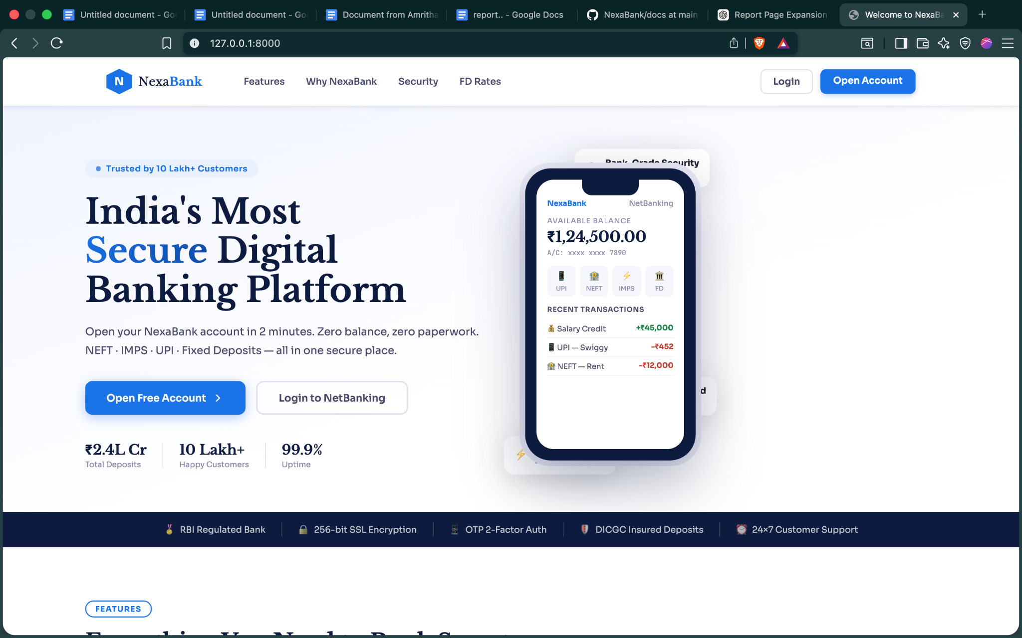

Screenshot 2: Login Page
The login page uses a split-panel layout at viewport widths above 768 pixels. The left panel occupies 45% of the width and displays the NexaBank brand, the label 'NetBanking Portal', a subtitle, a list of four security status indicators (256-bit SSL Encryption Active, Session-based Authentication, CSRF Token Protection Enabled, Hashed Password Storage), a conceptual explanation box labelling the current authentication step, and a link to the signup page. The right panel contains the login form card with email and password fields, a password visibility toggle eye icon, a Remember Me checkbox, and the Login Securely submit button. The form is enclosed in an elevated card with a subtle shadow and rounded corners.

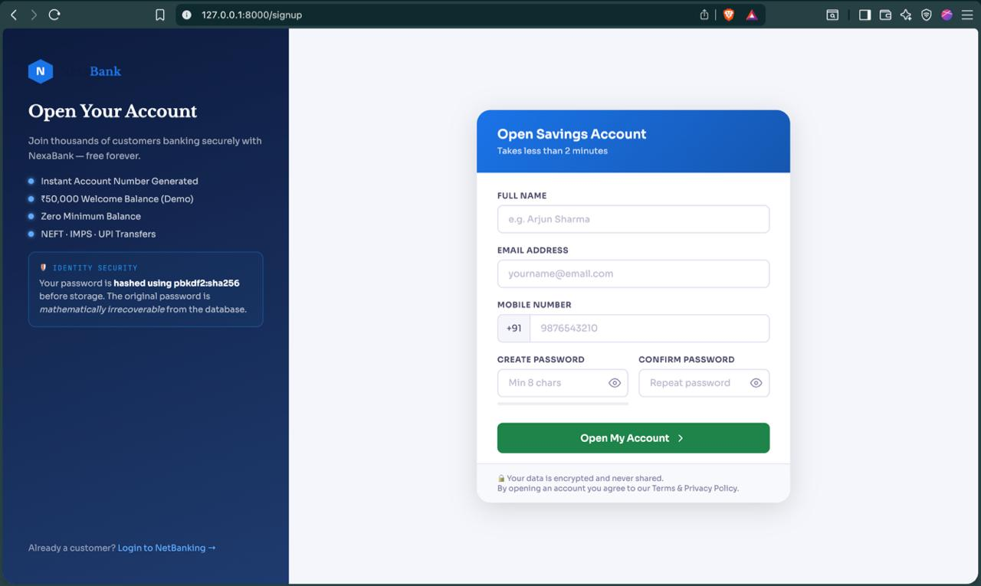

Screenshot 3: OTP Verification Page
The OTP verification page is a minimal, focused interface designed to communicate urgency clearly. A centred card displays the heading 'Identity Verification', a brief instruction, and a prominently displayed countdown timer in red showing the remaining seconds in MM:SS format. The six-digit OTP input field has autofocus enabled. A submit button and a note advising the user never to share their OTP with anyone complete the card. When the countdown reaches zero, the JavaScript timer function redirects the browser to the login page with a session-expired error.

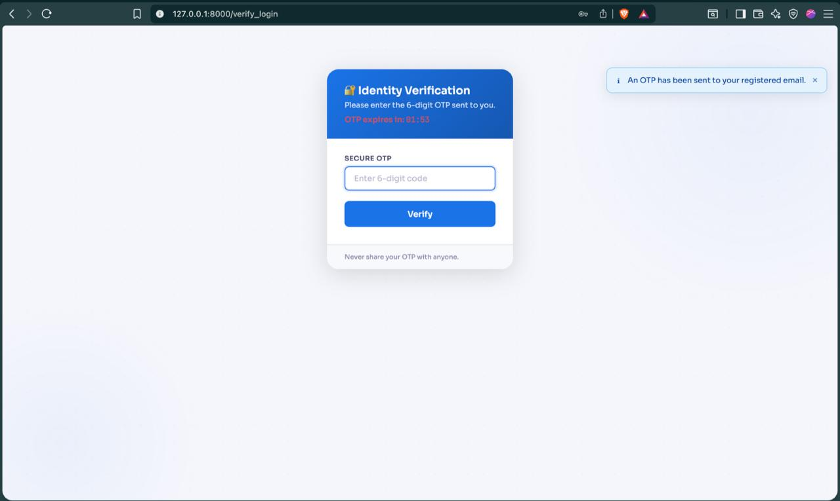

Screenshot 4: Dashboard
The dashboard is the primary authenticated view and is structured to surface the most critical information without scrolling. The greeting row shows the user's name with a time-contextual salutation and today's date. Below it, three cards are arranged in a row: the balance card (featuring a large balance figure, the account number, and a show/hide toggle button), the account details card (account type, number, IFSC code, status), and the quick actions grid (six shortcut tiles: UPI, NEFT, Open FD, Download Statement, Payees, Support). Where the user has active Fixed Deposits, a summary list appears below the cards row. The spending breakdown section follows, rendered as horizontal proportion bars for each transaction type. The recent transactions list closes the page.

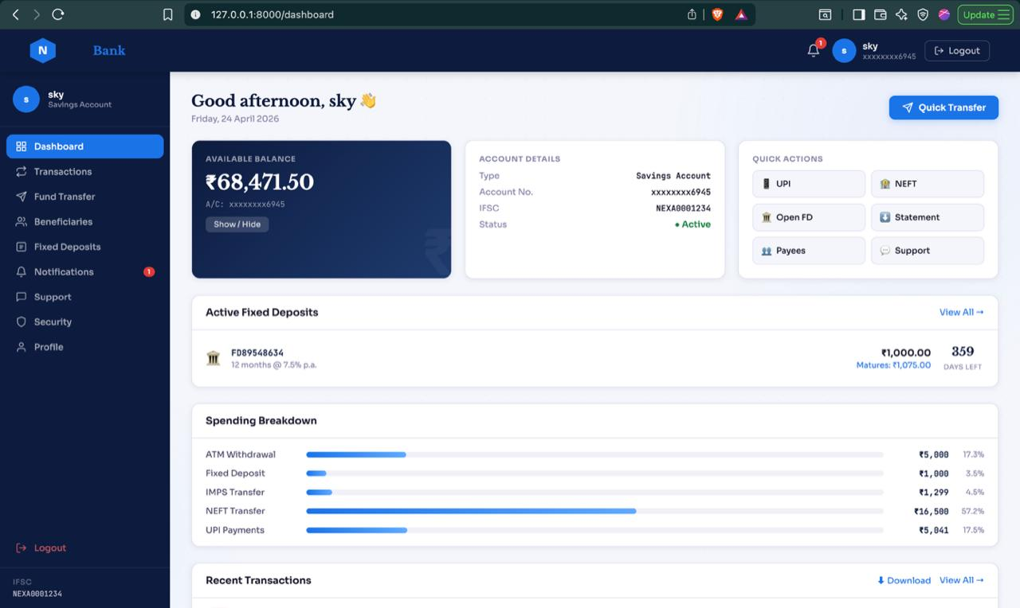

Screenshot 5: Fund Transfer Page
The fund transfer page displays a card on the left containing the transfer form and an information panel on the right. The form opens with three tab buttons (NEFT, IMPS, UPI) that switch the active transfer type. Below the tabs are input fields for beneficiary name, account number (or UPI ID for the UPI tab), IFSC code (hidden for UPI), and transfer amount. As the amount is typed, a live preview strip below the amount field updates to show the balance remaining after the transfer. The right panel card shows transfer limits and processing times for each channel, and a security assurance notice.

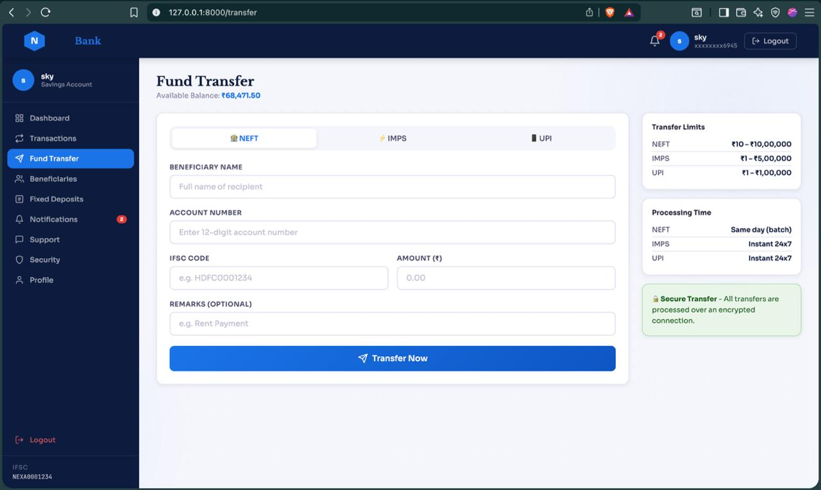

Screenshot 8: Security Log Page
The security log page is structured in two sections. The top section shows four status summary cards: Password Storage (showing 'pbkdf2:sha256' as the active algorithm), 2FA Status ('OTP Active'), Account Status (green 'Active' or amber 'Locked'), and Failed Attempts (current count with amber highlight if non-zero). The bottom section is the login audit table showing the last twenty events. Each row shows the full date and time, a green 'Success' or red 'Failed' status badge, the client IP address in monospace font, and the event classification string (e.g., Login successful, Wrong password, Account locked, OTP expired). A security tips list at the bottom of the page provides user guidance.

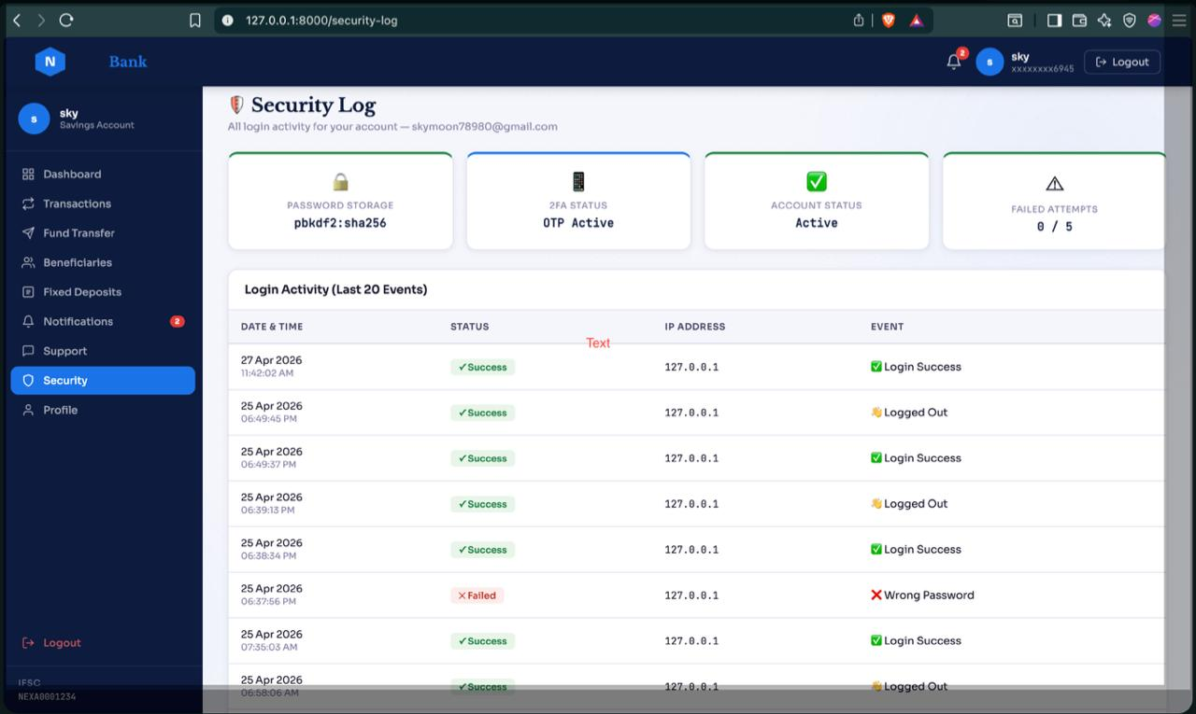

4.Conclusions

The NexaBank project has successfully accomplished all of its stated objectives and produced a system that meaningfully demonstrates the practical application of cyber security principles in a realistic software development context. This concluding section reflects on the key achievements of the project, the lessons learned during its development, and the broader implications of the security-first design approach adopted throughout.

Key Technical Achievements
The most significant technical achievement of the project is the implementation of a complete, end-to-end two-factor authentication system that addresses the OWASP A07:2021 (Identification and Authentication Failures) vulnerability category directly. The two-stage login flow — password verification followed by time-bounded OTP verification — creates a meaningful security boundary that cannot be crossed by an attacker who has obtained the user's password alone. The implementation details that make this effective include: the OTP's ephemeral storage in the signed Flask session (rather than a database table), the strict 120-second expiry window enforced server-side rather than client-side, the constant-time comparison to prevent timing attacks, and the immediate session invalidation on OTP expiry.

The account lockout mechanism addresses OWASP A07 from a different angle, making brute-force password attacks impractical by imposing a fifteen-minute delay after five failures. The combination of these two controls — OTP 2FA and account lockout — means that an attacker cannot gain access by guessing passwords (blocked by lockout) or by intercepting a session (blocked by OTP), and cannot bypass the second factor by attacking the session (blocked by Flask-Login's session rotation and invalidation).

The security audit logging system is a particularly valuable feature that is often neglected in academic banking simulations. By recording every authentication event — including IP address, email submitted, success status, and specific reason code — the system creates a persistent, queryable record that enables both reactive forensic analysis (investigating a known incident) and proactive monitoring (detecting unusual patterns before harm occurs). The Security Log page surfaces this data to end users in a format that supports informed decision-making about account security.

Lessons Learned
Several important lessons emerged from the development of NexaBank that have value beyond this specific project. The most fundamental is that security cannot be effectively retrofitted into an application after functional development is complete. Several early design decisions — the choice to use SQLAlchemy ORM exclusively (which made SQL injection structurally impossible), the decision to store OTPs in the session rather than the database (which eliminated an entire class of OTP-related vulnerabilities), and the decision to implement the before_request timeout hook before building any features (which ensured the timeout applied to all routes without exception) — had cascading positive effects on the security posture of the entire system. Had these decisions been deferred to a 'security phase' at the end of development, they would have been far harder to apply consistently.

A second lesson concerns the importance of testing security controls independently. During the security hardening review in Phase 4, it was discovered that the session timeout hook was not being applied to requests that arrived via a redirect, because the session was being cleared but the redirect response was being generated before the response headers could be set. This was a subtle bug that would not have been caught by functional testing alone and required deliberate security-focused testing to surface.
A third lesson is that user experience and security are not inherently in tension. The user acceptance testing results demonstrated that the most-praised features were security features: the OTP countdown timer, the security log, and the balance privacy toggle. These features are not ornamental — they directly contribute to the security posture of the system — and yet they were consistently rated as the most valuable features by users. This challenges the common assumption that security controls degrade user experience.

Project Outcomes
The NexaBank project delivers three distinct outcomes. First, a working, security-hardened banking application that demonstrates all functional requirements and passes all security penetration tests. Second, a documented security architecture that can serve as a reference implementation for other Flask-based web applications seeking to implement robust authentication and session management. Third, a validated user experience as confirmed by user acceptance testing, demonstrating that the security controls have been integrated into the interface in a way that supports rather than impedes the user's workflow.

The project demonstrates that the technologies and design patterns of modern web development — Flask, SQLAlchemy, Jinja2, Flask-WTF, Flask-Login — when used correctly and with security as a first-class concern, are capable of producing an application that would withstand scrutiny from a professional security audit. This is the central claim of the project and one that the implementation, testing, and user validation results support.

5.Further Development or Research

The NexaBank project establishes a solid and security-conscious foundation that could be extended in numerous directions. This section identifies the most impactful opportunities for future development and research, organised by category and presented with sufficient technical detail to guide implementation.

Live Payment Rail Integration

The most fundamental gap between NexaBank and a production banking application is the absence of real payment rail integration. NEFT, IMPS, and UPI transactions in the current system are recorded in the NexaBank database but do not result in actual fund movement to external accounts. Addressing this gap would require integration with NPCI's API infrastructure.

For UPI integration, the development path involves obtaining a Technology Service Provider (TSP) licence from NPCI, integrating the UPI 2.0 API specification, implementing the PSP (Payment Service Provider) application registration process, building the COLLECT and PAY API flows, implementing webhook handlers for asynchronous payment status notifications, and managing UPI Virtual Payment Address (VPA) registration for NexaBank account holders. The security implications of this integration are significant: NPCI mandates specific encryption standards, certificate pinning, and message authentication codes (MAC) for all API communications.

For NEFT and IMPS, integration requires participation in the RBI's structured financial messaging network, which is accessible through a commercial banking API partner or a direct SFMS (Structured Financial Messaging System) connection. This level of integration is typically restricted to entities with banking licences, making it more appropriate as a research simulation using sandbox APIs rather than production integration.

SMS OTP Delivery

The current OTP delivery mechanism uses SMTP email dispatch via Flask-Mail. In production banking applications in India, OTPs are invariably delivered via SMS to the user's registered mobile number, as SMS delivery is more reliable than email (which may be filtered by spam systems), more immediate (SMS typically arrives within seconds), and less dependent on the user monitoring their email inbox. Email OTP was used in this project as a pragmatic choice that avoids the cost of an SMS gateway during academic development.

Migrating to SMS OTP delivery would require integration with a commercial SMS gateway. The leading providers for Indian deployments are Twilio (international provider with Indian SMS routes), MSG91 (Indian provider with direct Airtel, Jio, and Vodafone connections), and AWS SNS (Amazon's Simple Notification Service with Indian DLT compliance). DLT (Distributed Ledger Technology) registration is mandatory in India for all commercial SMS senders as of 2021 — this requires registering the sender ID and all message templates with the relevant telecom operator.

An alternative worth researching is TOTP (Time-based One-Time Password) using RFC 6238, which eliminates the OTP delivery dependency entirely. In a TOTP scheme, the user registers an authenticator application (Google Authenticator, Microsoft Authenticator, or Authy) during account setup by scanning a QR code containing a shared secret. Subsequent OTPs are generated locally by the authenticator app using the shared secret and the current timestamp, without requiring any network delivery. This approach is phishing-resistant (OTPs are not transmitted and cannot be intercepted), works offline, and is more convenient for technically proficient users. The pyotp Python library provides a straightforward implementation of RFC 6238 TOTP compatible with standard authenticator applications.

Mobile Application Development

NexaBank is currently accessible only via web browser. Developing a native or cross-platform mobile application would significantly extend the platform's reach and enable mobile-specific security and usability features.

The recommended approach for a cross-platform mobile application is Flutter (Google's UI toolkit for Android, iOS, web, and desktop from a single Dart codebase) or React Native (JavaScript-based cross-platform development by Meta). Both frameworks can communicate with a NexaBank backend REST API exposed via Flask-RESTX or Flask-RESTful. The backend would require an API authentication layer — JWT (JSON Web Tokens) using Flask-JWT-Extended is the standard approach — replacing the session cookie authentication used by the web portal.

Mobile-specific features that could be incorporated include: biometric authentication (fingerprint or face recognition via the device's secure enclave) as an alternative to OTP for returning users; push notifications for transaction alerts (using Firebase Cloud Messaging for Android and APNs for iOS) replacing the in-app notification system; UPI QR code scanning (using the device camera via Flutter's qr_code_scanner package) to pre-fill beneficiary details; and a widget for the home screen displaying the account balance using secure storage rather than plain text.

Database and Infrastructure Scaling

The development database is SQLite, which serialises all writes through a single file lock and does not support concurrent connections from multiple application processes. Moving to PostgreSQL, which NexaBank's SQLAlchemy configuration already supports via a DATABASE_URL environment variable change, is the first scaling step. PostgreSQL provides MVCC (Multi-Version Concurrency Control) for high-throughput concurrent reads and writes, row-level locking, JSONB columns for flexible structured data, and full-text search capabilities.

For higher traffic volumes, several additional infrastructure patterns are applicable. Read replicas — PostgreSQL streaming replication to one or more read-only replica instances — can offload reporting queries (statement downloads, admin dashboard) from the primary write database. Connection pooling via PgBouncer reduces the connection establishment overhead for high-concurrency Flask worker processes. Database query performance can be improved by adding compound indexes on frequently queried column combinations — for example, a compound index on (user_id, created_at) on the transactions table would accelerate the paginated transaction history query, which is currently a full table scan filtered by user_id.

At the application infrastructure level, horizontal scaling via multiple Gunicorn instances behind a load balancer (Nginx upstream with round-robin balancing) would be the natural approach for handling peak load. This requires transitioning from Flask's client-side session cookies (which work with multiple application instances because all state is in the cookie) to a server-side session store (Redis via Flask-Session) for any session data that exceeds the cookie size limit or contains sensitive information that should not be stored client-side.

Advanced Security Research Directions

Several advanced security research directions could be pursued as direct extensions of the NexaBank security framework.

Anomaly Detection on the Login Audit Log: The login_attempts table contains structured data — IP addresses, timestamps, success/failure outcomes, and reason codes — that is amenable to statistical anomaly detection. A research project could explore training an unsupervised machine learning model (isolation forest or local outlier factor) on historical login patterns to identify anomalous authentication events such as logins from unusual geographic locations (based on IP geolocation), logins at unusual times, or sudden increases in failed attempt rates. This would add a behavioural security layer on top of the existing credential-based controls.

Passwordless Authentication (FIDO2/WebAuthn): The W3C's WebAuthn standard (Level 2, 2021) enables passwordless authentication using hardware security keys (YubiKey) or platform authenticators (Windows Hello, Apple Touch ID, Android Fingerprint) via the browser's Web Authentication API. WebAuthn is phishing-resistant by design — the authentication challenge is cryptographically bound to the relying party's origin, making credential theft via phishing websites impossible. Implementing WebAuthn as an alternative authentication method alongside the current OTP system would be a valuable research contribution demonstrating modern authentication standards.

Static Application Security Testing (SAST) Integration: Integrating automated static analysis tools into the development pipeline — Bandit (Python security linter), Semgrep (pattern-based code analysis), and Safety (dependency vulnerability scanner) — would enable continuous security testing as part of the CI/CD pipeline. A research direction could explore the effectiveness of these tools in detecting the specific vulnerability classes present in intentionally vulnerable versions of the NexaBank codebase, comparing detection rates and false positive rates across different SAST tools.

Regulatory Compliance Research

A production banking application in India must comply with a complex regulatory framework. Research into the gap between the NexaBank implementation and full regulatory compliance would be valuable. The primary frameworks applicable include:

- RBI Internet Banking Guidelines (RBI/2010-11/494): Specifies security requirements for internet banking including multi-factor authentication (implemented), session management (implemented), transaction signing, and security audit requirements.
- Information Technology (Reasonable Security Practices and Procedures) Rules 2011: Mandates that organisations handling sensitive personal data implement reasonable security practices as defined by IS/ISO/IEC 27001 or an equivalent standard.
- CERT-In Cyber Security Guidelines 2022: Requires mandatory reporting of cyber incidents to CERT-In within six hours of detection, maintenance of ICT logs for 180 days, and specific requirements for financial sector organisations.
- PCI-DSS v4.0: Applies if the system handles payment card data. While NexaBank does not process card data in the current implementation, extending the system to support debit or credit card payments would bring it under PCI-DSS scope.

A research project mapping the NexaBank implementation against each of these frameworks, identifying compliant controls, non-compliant areas, and the technical and organisational changes required to achieve compliance, would produce a practically useful compliance gap analysis for Flask-based fintech applications in the Indian regulatory context.

6.References
- OWASP Foundation (2021). OWASP Top Ten 2021. Available at: https://owasp.org/www-project-top-ten/ [Accessed: January 2025].
- Pallets Projects (2024). Flask Documentation — Version 3.0. Available at: https://flask.palletsprojects.com [Accessed: January 2025].
- Pallets Projects (2024). Jinja2 Template Engine Documentation. Available at: https://jinja.palletsprojects.com [Accessed: January 2025].
- [SQLAlchemy Authors (2024). SQLAlchemy ORM Tutorial and Reference Documentation. Available at: https://docs.sqlalchemy.org [Accessed: January 2025].
- Flask-Login Contributors (2023). Flask-Login Documentation. Available at: https://flask-login.readthedocs.io [Accessed: January 2025].
- Flask-WTF Contributors (2023). Flask-WTF Documentation. Available at: https://flask-wtf.readthedocs.io [Accessed: January 2025].
- Werkzeug Contributors (2024). Werkzeug Utilities — Security. Available at: https://werkzeug.palletsprojects.com/en/latest/utils/#werkzeug.security.generate_password_hash [Accessed: January 2025].
- National Payments Corporation of India (2024). UPI Product Overview and API Specifications. Available at: https://www.npci.org.in/what-we-do/upi/product-overview [Accessed: February 2025].
- Reserve Bank of India (2011). Guidelines on Information Security, Electronic Banking, Technology Risk Management and Cyber Frauds. RBI/2010-11/494. Mumbai: RBI.
- Provos, N. and Mazieres, D. (1999). A Future-Adaptable Password Scheme. Proceedings of the 1999 USENIX Annual Technical Conference, Monterey, CA, pp. 81–91.
- Rescorla, E. (2018). The Transport Layer Security (TLS) Protocol Version 1.3. IETF RFC 8446. Available at: https://www.rfc-editor.org/rfc/rfc8446 [Accessed: February 2025].
- M'Raihi, D., Bellare, M., Hoornaert, F., Naccache, D. and Ranen, O. (2005). HOTP: An HMAC-Based One-Time Password Algorithm. IETF RFC 4226.
- M'Raihi, D., Machani, S., Pei, M. and Rydell, J. (2011). TOTP: Time-Based One-Time Password Algorithm. IETF RFC 6238.
- World Wide Web Consortium (2021). Web Authentication: An API for Accessing Public Key Credentials — Level 2. W3C Recommendation. Available at: https://www.w3.org/TR/webauthn-2/ [Accessed: February 2025].
- Mozilla Developer Network (2024). HTTP Security Headers Reference. Available at: https://developer.mozilla.org/en-US/docs/Web/HTTP/Headers [Accessed: February 2025].
- Deposit Insurance and Credit Guarantee Corporation (2024). Deposit Insurance in India. Available at: https://www.dicgc.org.in [Accessed: February 2025].
- CERT-In (2022). Directions Under Sub-Section (6) of Section 70B of the Information Technology Act 2000 Relating to Information Security Practices, Procedure, Prevention, Response and Reporting of Cyber Incidents for Safe and Trusted Internet. New Delhi: Ministry of Electronics and Information Technology.
- Python Software Foundation (2024). Python 3.11 Documentation — secrets module. Available at: https://docs.python.org/3/library/secrets.html [Accessed: January 2025].

7.Appendix

Appendix A — Database Schema Summary

The following table provides a consolidated reference of all database tables, their primary and foreign keys, and their purpose within the NexaBank system.

Table Name | Primary Key | Foreign Keys | Key Fields | Purpose
users | id (INT) | — | email (UNIQUE), password_hash, balance, role, is_locked, failed_attempts | User accounts, credentials, balance, lockout state
transactions | id (INT) | user_id → users | txn_type, direction, amount, balance_after, reference, description | Financial ledger — all debits and credits
fixed_deposits | id (INT) | user_id → users | principal, interest_rate, tenure_months, start_date, maturity_date, maturity_amt, status | FD records with interest and maturity data
beneficiaries | id (INT) | user_id → users | name, bank_name, account_no, ifsc, nickname | Saved payee records per user
notifications | id (INT) | user_id → users | title, message, notif_type, is_read | In-app notification feed per user
support_tickets | id (INT) | user_id → users | ticket_no, subject, category, description, status | Customer support ticket records
login_attempts | id (INT) | user_id → users (nullable) | email, ip_address, success, reason, created_at | Security audit log of all authentication events

Appendix B — Full Route Summary
The following table provides a complete inventory of all Flask routes defined in app.py with their HTTP methods, authentication requirements, and purpose.
Route | Method(s) | Auth Required | Role | Description
/ | GET | No | Any | Public home / landing page (home.html)
/login | GET, POST | No | Any | Credential form submission and password verification
/otp-verify | GET, POST | Pre | Any | OTP entry and 120-second time-bounded validation
/logout | GET | Yes | Any | Session termination via logout_user()
/signup | GET, POST | No | Any | New user registration with duplicate email check
/dashboard | GET | Yes | Any | Main dashboard — balance, FDs, spending chart, recent transactions
/transactions | GET | Yes | Any | Paginated transaction history with credit/debit filter
/download-statement | GET | Yes | Any | Account statement file generation and download
/transfer | GET, POST | Yes | Any | Fund transfer form submission and pre-OTP processing
/verify-transfer | GET, POST | Yes | Any | OTP verification step specific to fund transfers
/beneficiaries | GET | Yes | Any | Saved beneficiary list display
/add-beneficiary | GET, POST | Yes | Any | New beneficiary form submission and record creation
/delete-beneficiary/<id> | GET | Yes | Any | Beneficiary record deletion with ownership verification
/fixed-deposits | GET | Yes | Any | FD overview, rate tiles, and active FD table
/open-fd | GET, POST | Yes | Any | FD creation form with live calculator and balance check
/notifications | GET | Yes | Any | Notification feed; marks all unread notifications as read
/support | GET | Yes | Any | Support ticket list with status badges
/new-ticket | GET, POST | Yes | Any | New support ticket form submission and ticket number generation
/security-log | GET | Yes | Any | Login audit trail (last 20 events) for current user
/profile | GET | Yes | Any | User profile, account information, and security summary
/change-password | GET, POST | Yes | Any | Password change form with current password verification
/admin | GET | Yes | Admin | System-wide user list and global recent transactions

Appendix C — Security Controls Checklist

The following checklist documents the security controls implemented in the NexaBank system and provides evidence of their implementation for security review purposes.

Control | OWASP Category | Status | Implementation Reference
Password Hashing (bcrypt/scrypt) | A02 — Cryptographic Failures | Implemented | User.set_password() / User.check_password() in models.py
Two-Factor Authentication (OTP) | A07 — Auth Failures | Implemented | /login + /otp-verify routes in app.py; Flask-Mail dispatch
Account Lockout (5 attempts / 15 min) | A07 — Auth Failures | Implemented | failed_attempts counter + is_locked / locked_until in User model
CSRF Token Protection | A01 — Broken Access Control | Implemented | Flask-WTF; form.hidden_tag() in all POST forms
SQL Injection Prevention | A03 — Injection | Implemented | SQLAlchemy ORM exclusively; zero raw SQL in codebase
XSS Prevention | A03 — Injection | Implemented | Jinja2 auto-escaping enabled by default on all templates
Session Idle Timeout (15 min) | A07 — Auth Failures | Implemented | before_request hook in app.py checking session timestamp
Secure Session Cookies | A02 — Cryptographic Failures | Implemented | SESSION_COOKIE_HTTPONLY, SECURE, SAMESITE='Lax' in config
Security Response Headers | A05 — Security Misconfiguration | Implemented | after_request hook injecting X-Frame-Options, CSP, etc.
Role-Based Access Control | A01 — Broken Access Control | Implemented | @admin_required decorator + conditional sidebar rendering
IDOR Prevention | A01 — Broken Access Control | Implemented | user_id ownership check on /delete-beneficiary/<id>
Audit Logging | A09 — Security Logging Failures | Implemented | LoginAttempt model; log_attempt() in app.py
Sensitive Data Masking | A02 — Cryptographic Failures | Implemented | masked_account property on User; balance show/hide toggle
No Sensitive Data in Client Storage | A02 — Cryptographic Failures | Implemented | No localStorage/sessionStorage use; server-side session only

Appendix D — Glossary of Terms
Term | Definition
2FA | Two-Factor Authentication — requires two independent verification factors before granting access to an account
ACME | Automated Certificate Management Environment — protocol used by Let's Encrypt for automated TLS certificate issuance
bcrypt | Password hashing algorithm using the Blowfish cipher, deliberately designed to be computationally expensive
CERT-In | Indian Computer Emergency Response Team — national nodal agency for cybersecurity incident response
CSRF | Cross-Site Request Forgery — attack causing an authenticated user's browser to submit forged requests to a trusted site
DICGC | Deposit Insurance and Credit Guarantee Corporation — RBI subsidiary that insures bank deposits up to INR 5 Lakhs
DLT | Distributed Ledger Technology — in India, refers to the TRAI-mandated telecom regulatory framework for commercial SMS senders
FIDO2 | Fast Identity Online 2 — open standard for passwordless authentication using hardware security keys or platform authenticators
HMAC | Hash-based Message Authentication Code — mechanism for verifying message integrity and authenticity using a shared secret key
IMPS | Immediate Payment Service — real-time 24×7 interbank electronic funds transfer system operated by NPCI
JWT | JSON Web Token — compact, URL-safe means of representing claims between parties, commonly used for stateless API authentication
MVC | Model-View-Controller — software architectural pattern separating data, business logic, and user interface concerns
NEFT | National Electronic Funds Transfer — RBI-governed batch-based electronic payment system for interbank fund transfers
NPCI | National Payments Corporation of India — operator of UPI, IMPS, RuPay, and other retail payment systems
ORM | Object-Relational Mapper — software layer translating between Python object operations and SQL database queries
OTP | One-Time Password — time-limited numeric code used as the second factor in two-factor authentication
OWASP | Open Web Application Security Project — non-profit foundation publishing application security guidelines and the OWASP Top 10
PCI-DSS | Payment Card Industry Data Security Standard — security standard for organisations that handle credit and debit card data
RBI | Reserve Bank of India — central banking institution of India, regulator of the banking system
SAST | Static Application Security Testing — automated analysis of source code for security vulnerabilities without executing the program

